Short-Term Rockburst Prediction in TBM Tunnels
Jack Mierzejewski
Principal Engineer – Tunnels, Multiconsult AS, Norway.
Gary Peach
Resident Engineer –TBM, Multiconsult AS, Norway.
Bruce Ashcroft
Tunnel Engineer –TBM, Multiconsult AS, Norway.

ABSTRACT: Rockbursts in the tight confines of a TBM tunnel can be highly hazardous events given the proximity of vital equipment and workers to the rockburst source, and the space constraints that severely limit employment of countermeasures. Consequently, the ability to predict rockbursts with some measure of confidence as excavation proceeds (i.e. in the ‘short-term’) is critical to the safety of both workers and equipment. The Neelum Jhelum project in the Azad Kashmir region of northeast Pakistan, with twin 8.5 m diameter main-beam gripper TBMs operating under high horizontal stresses and overburdens up to 1,870 m, encountered rockbursts, prompting development of an investigative system to predict these events. The system relies on analysis of probing data, TBM boring parameters and above all, a sophisticated microseismic detection and analysis capability. Investigation techniques that failed to give useful results, or were not implemented for other reasons, are also discussed.

Introduction
The Neelum Jhelum hydroelectric project is located in the Muzaffarabad district of Azad Jammu & Kashmir (AJK), in northeastern Pakistan. Geographically, the area consists of rugged terrain between 500 and 3,200 m in elevation within the Himalayan foothill zone known as the Sub-Himalayan Range.
The project is a run-of-river one, employing 28.6 km long headrace and 3.6 km long tailrace tunnels to cut off a major loop in the river system, transferring the waters of the Neelum River into the Jhelum River, for a total head gain of 420 m (Figure 1). The headrace tunnels comprise both twin (69 %) and single (31 %) tunnels, while the tailrace tunnel consists of a single tunnel. Design capacity of the waterway system is 283 cumecs.
When completed, the project will have an installed capacity of 969 MW, generated by four Francis-type turbines located in an underground powerhouse.
At commencement of construction in 2008, all tunnels were to be excavated using conventional drill & blast techniques. However, it soon became apparent that with the equipment being employed, a 13.5 km long section of the headrace twin tunnels underlain by high terrain that precludes construction of additional access adits, would take too long to excavate.
Consequently, the construction contract was amended to allow the operation of two 8.5 m diameter main-beam gripper hard rock TBMs to each excavate some 10 km of the twin headrace tunnels (Figure 1). The tunnel excavation diameter is 8.5 m diameter giving a total face area of 56.75 m², with a 6 m long shield.
The main-beam gripper design was selected to give the most flexibility for the expected conditions – possible squeezing ground given the relatively weak rock mass and overburden up to 1,870 m, and the potential for rockbursts in the stronger beds. Excavation of the TBM tunnels commenced in January 2013.

GEOLOGICAL SETTING
The entire project is being excavated in the molasse-type sedimentary rocks of the Murree Formation, which is of Eocene to Miocene age,
and the lateral equivalent of the Siwalik Group in India. The succession comprises intercalated beds of sandstone, siltstone and mudstone that have been tightly folded and tectonized, with generally steep bedding dips and a northwesterly regional bedding strike, rarely far from perpendicular to the tunnel azimuth.
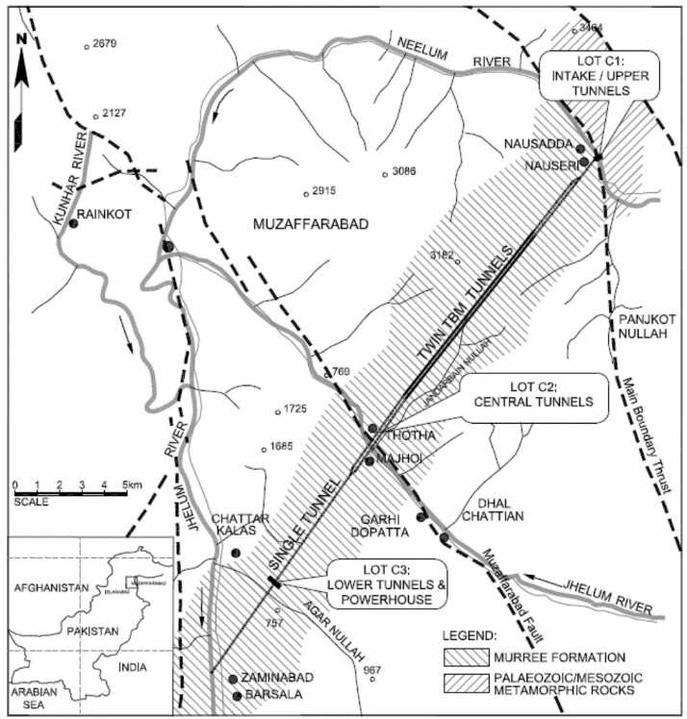
Figure 1. Neelum Jhelum project layout showing TBM Twin tunnels (in bold), major faults (dashed) and alignment geology.
Weakness zones and local faults are commonly observed, and are invariably oriented parallel to the regional bedding strike.
The TBM tunnels are being driven within the central portion of a zone bounded by two major active Himalayan faults that trend sub-perpendicular to the tunnels: the Main Boundary Thrust, a bounding fault that extends for the full length of the Himalayan range that approximately follows the course of the Neelum River at the upstream start of the headrace tunnels at Nauseri, and a subsidiary reverse/thrust fault named the Muzaffarabad Fault that runs close to the course of the Jhelum River at Thotha (Figure 1), beneath which the project’s twin headrace tunnels pass. Rupture along this fault in 2005 resulted in the Muzaffarabad earthquake that caused over 75,000 fatalities.

Lithologies

Mudstones
Mudstones, which also are dark reddish-brown, represent the weakest rocks in the Murree sequence, with UCS’s in the 30 to 40 MPa range, but with the sheared mudstone sub-group (about 16 % of all mudstones) exhibiting significantly weaker properties. Mudstones make up approximately 9 % of the total TBM tunnel length, usually occurring as discrete beds of 2 m thickness or less.

Siltstones & Silty Sandstones
A suite of dark reddish-brown siltstones that commonly grade to silty sandstones constitutes the most commonly occurring rock type on the project, with about 70 % of the TBM tunnels excavated in this unit. These rocks typically have uniaxial compressive strength (UCS) values in the 50-70 MPa range.

Sandstones
In contrast to the reddish-brown colouration of most of the Murree lithologies, these strongest members of the Murree sequence are usually grey, with sharply defined contacts, characteristics that make sandstones easily distinguishable in exposures and drill holes. To date about 21 % of the TBM tunnels had been excavated in this unit. Bedding thickness is highly variable, from a few metres to in excess of 50 m.
Laboratory test data at the start of the project had indicated mean UCS’s of about 90 MPa in this unit, but subsequent tests on samples taken from beds that had produced rockbursts have given significantly higher results. Of the 30 samples tested recently, 77 % gave results in the 130-170 MPa range, with the remaining 23 % exhibiting higher strengths, up to 230 MPa. The majority of rockbursts have occurred in these sandstones.

In-situ Stresses
In-situ stress measurements for the project were initially directed at the two locations where overburden is most critical: the crossing of the twin headrace tunnels under the Jhelum River and at the underground powerhouse (Figure 1). Hydrojacking and, less successfully, hydrofracking have given somewhat variable results, thought to be the consequence of the anisotropic nature rock sequence, with large variations in stiffness between sandstones and mudrocks.
Nevertheless, most of the results were loosely clustered around a horizontal-to-vertical stress ratio (k) of unity, even though high horizontal stresses might have been expected parallel to the tunnel axis, given that the motion of the Indian tectonic plate approximately parallels the tunnel azimuth. Indeed, this is the major principal stress orientation indicated by the World Stress Map (Heidbach et al, 2008).
A similar stress regime to that indicated by the in-situ stress measurements had been anticipated for the TBM tunnels, despite the higher overburdens (Figure 2). However, subsequent in-situ stress measurements performed by overcoring in sandstone beds in the TBM tunnels, initiated to investigate the rockburst phenomenon, have indicated significantly higher stresses (k up to 2.9) where the major principal stress is oriented sub-horizontally, and nearly perpendicular to the tunnel azimuth.
The programme of stress measurements by overcoring, which employed CSIRO hollow inclusion cells, was attempted at 12 locations in both left and right TBM tunnels. Severe discing of the drill core (the fracturing of core into thin discs normal to the long axis) was encountered at four of these locations, precluding employment of this test method. Of the remaining 8 locations, two experienced some discing that led to questionable results, leaving a total of 6 satisfactory test results.
The programme identified a zone of highly elevated horizontal stresses, as can be seen by the plotted k values (horizontal: vertical stress ratio, transformed to tunnel orientation) in the bottom section of Figure 2. The indicated boundaries of this zone are of necessity based on the limited test results, and may extend further upstream and downstream than shown.

Rockbursts
No rockbursts were encountered in the initial 2.3 km of either TBM tunnel, at which point rockbursts in both tunnels commenced but incidence remained low. However, when 4.7 km (45 %) of the left tunnel had been completed, the
number and magnitude rockbursts increased dramatically, occurring on a regular enough basis to merit systematic recording.

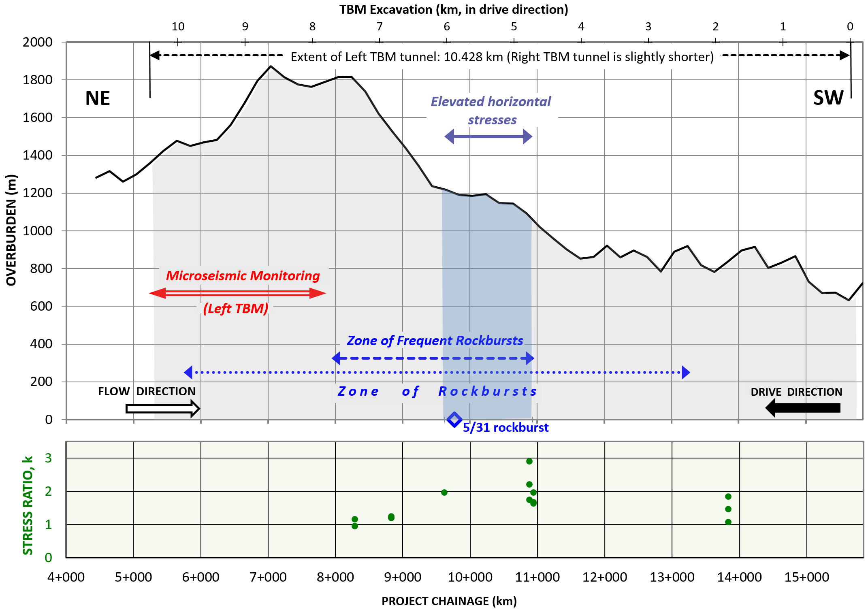Figure 2. TBM alignment profile (vertical exaggeration x 2.75) showing overburden, zones of rockbursting and elevated horizontal stresses (latter determined from overcoring). Grey shading corresponds to TBM-excavated tunnel (kilometres excavated shown on upper scale). Lower chart shows H:V stress ratio, k, also determined from overcoring, transformed to tunnel orientation.
(The data presented in this paper relates principally to the left TBM, which has completed its drive. At the time of writing, the right TBM has yet to finish.) The high incidence of rockbursts continued for 2.9 km, before lessening once more (Figure 2). The last 515 m of the 10.428 km long left tunnel were completed without incident.
By far the majority of rockbursts (81 %) occurred within sandstone beds, while the remaining 19 % occurred within massive siltstone beds, usually in close proximity to sandstone beds.
The rockbursts encountered on the project were all self-initiated strainbursts, in contrast to events that may be triggered by distant seismic events. In a strainburst-type rockburst, rock mass fracturing and dilation occur when the stresses near the opening exceed the rock mass strength and excess energy is released in an unstable and violent manner. The primary source of energy causing the rock fracturing and dilation comes from the strain energy stored in the rock around the opening (Kaiser & McCreath, 1993).

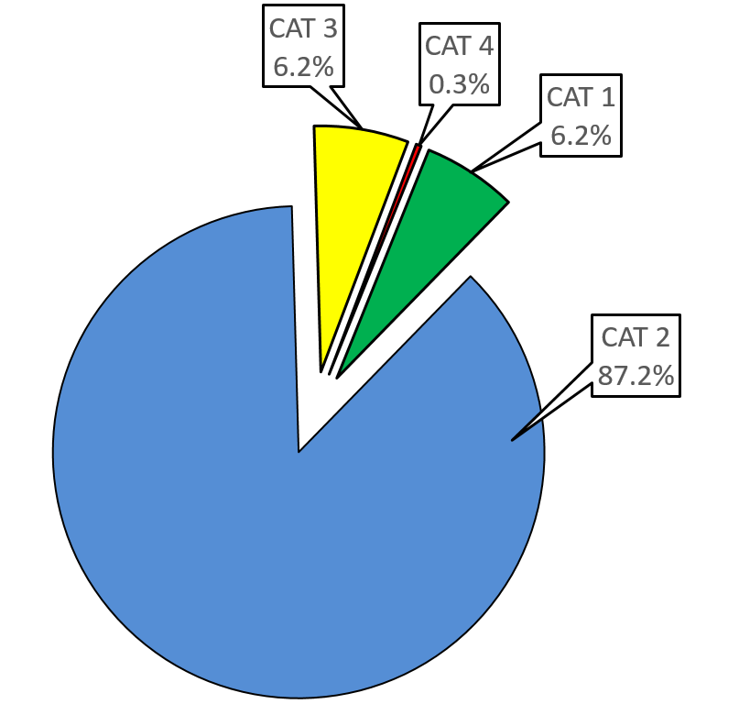
Rockburst Classification
The Canadian Rockburst Support Handbook (Kaiser P.K. et al, 1996) defines rockbursts as “damage to an excavation that occurs in a sudden or violent manner and is associated with a seismic event.” This definition is widely used in the mining industry, but was considered too specific for the Neelum Jhelum project. Instead, the term “rockburst” was expanded to refer to any release of detectable seismic energy linked with the excavation of the TBM tunnels.
Consequently, the term “rockburst” as used on the project does not necessarily imply that damage was caused to the tunnel excavation or to the TBM. Instead, abrupt loud pistol-shot noises, or small ejections of rock that cause no damage but indicate release of seismic energy are classed as rockbursts. This broader definition was adopted because even such small events may affect the operation of the TBM, and can be predictors of larger events.
The rockbursts have been categorised by magnitude as follows, based on their characteristics:

- CATEGORY 1: Noise only: a pistol shot sound caused by energy release that causes no damage to the rock support or ejection of rock.
- CATEGORY 2: Noise and weak rockburst: a pistol shot sound caused by energy release causing light damage to the rock support and surrounding rock (e.g. cracking in the shotcrete and rock).
- CATEGORY 3: Noise and medium rockburst: loud sounds caused by energy release causing ejection of rock fragments, spalling or shallow slabbing to the rock support and surrounding rock and damage to TBM components.
- CATEGORY 4: Noise and major rockburst: loud sound similar to an explosion, violent ejection of rock into the tunnel and severe damage to the installed support and possibly TBM equip-ment.
Figure 3 shows the frequency distribution of rockbursts by magnitude in the left TBM tunnel. A total of 879 rockbursts were recorded, of which 55 were of Category 3 magnitude or greater.

Figure 3: Rockburst distribution by magnitude-left TBM tunnel
Later in the project, the need for a more rigorous rockburst classification conforming to international standards became apparent. Several classifications systems were reviewed before selecting the Chinese Academy of Science’s Institute for Rock and Soil Mechanics (IRSM) interpretation (Chen B.R et al, 2015) of the classification system included in Chinese Code GB 50487 (Code of China, 2008). As of this writing, the conversion to this database has yet to be accomplished, and thus the project-based system is used throughout this paper.
The cumulative rockburst count by chainage, presented in chronological order as they occurred, is presented in Figure 4. While most of the rockbursts occurred within 10 m of the face, a number occurred further back in the TBM. These are recognizable as points displaced to the right of the main curve in Figure 4.
The “5/31 rockburst” shown in Figure 4 refers to the most severe rockburst on the project, which occurred on 31st May 2015 in the right TBM, which at the time was trailing by 180 m. This event, which equated to a 2.4 magnitude earthquake, severely damaged the TBM, with the recovery operation taking 7 months to return the TBM into operational condition. An unusual set of geological conditions, with the bedding strike locally running parallel to tunnel direction, and unrecognized massive sandstone beds in the sidewalls masked by siltstone, significantly contributed to the severity of this event. Damage extended across the 24.5 m wide pillar into the left TBM, which had earlier driven through this zone without difficulties.
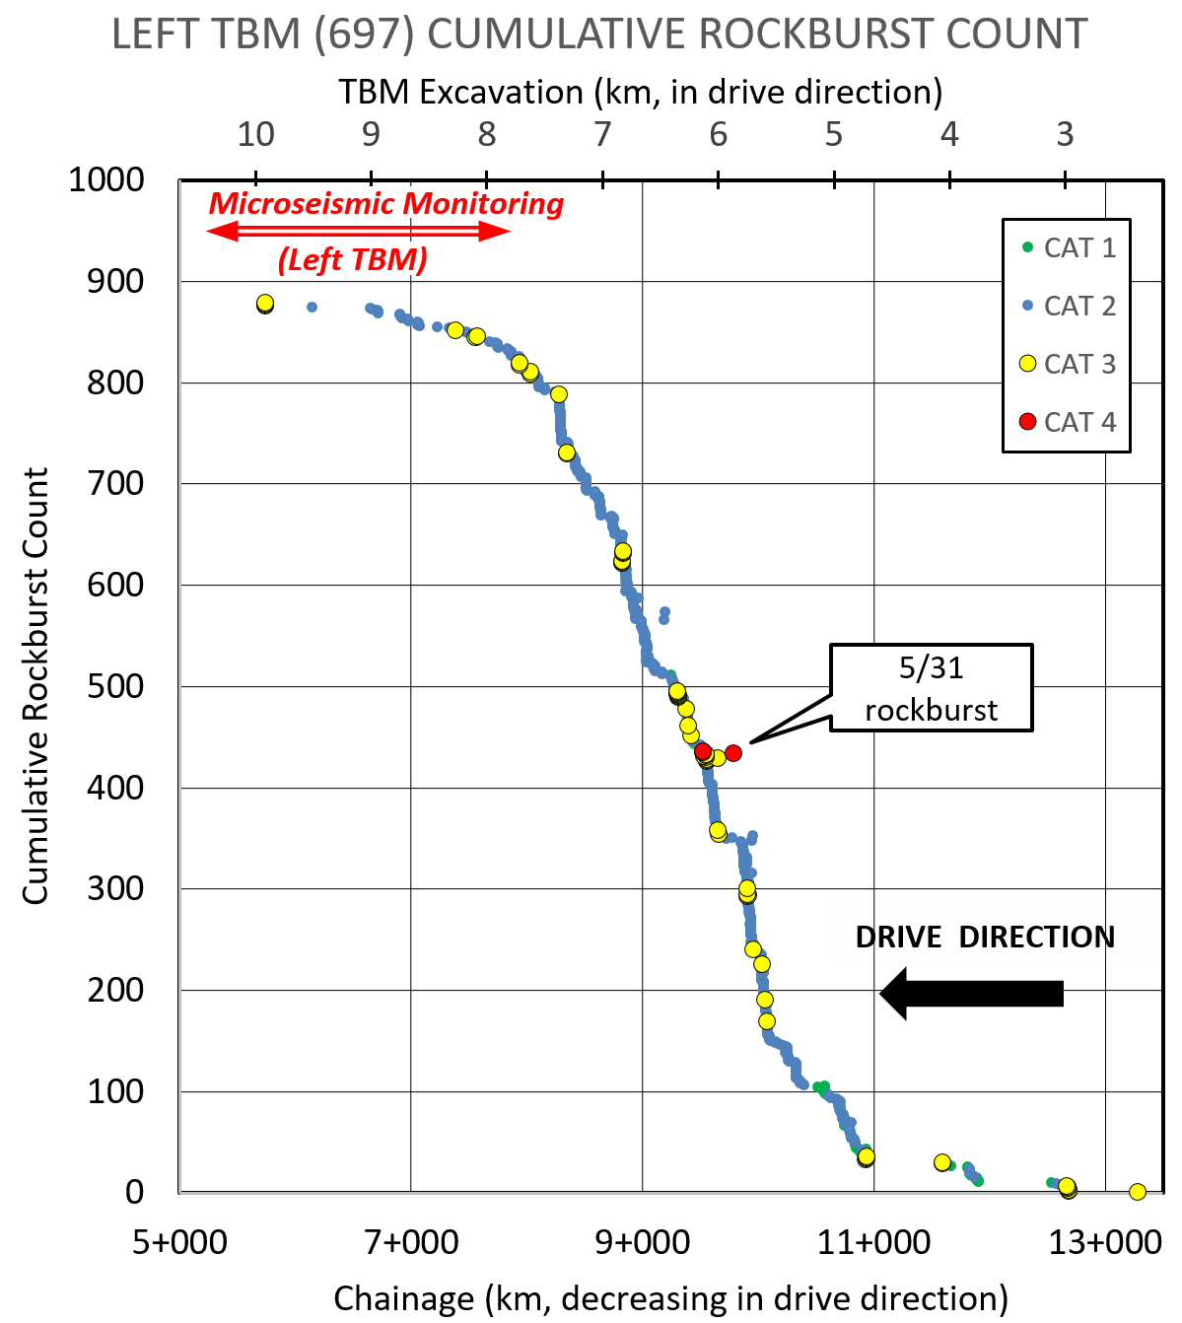
Figure 4: Cumulative rockburst count for Left TBM, by chainage, in chronological order of occurrence.
While the elevated horizontal stresses undoubtedly played a major role in the severity of the rockbursts, the zone of high frequency rockbursts appears also to correspond to a deeply eroded valley beneath which the TBM was excavating. The frequency of rockbursts declined dramatically when surface topography switched from a creek valley to a ridgeline. Whether this is significant or not is currently unknown.

TBM Operational Activity During Rockbursts
Analysis of rockburst data shows that the majority of rockbursts (64.5 %) occurred while the TBM was excavating, as might be expected given the reorientation of stresses that excavation causes.
Nearly a third (29.9 %) of rockbursts occurred while the rock support was being installed in the L1 zone (the 4 m-long working area behind the shield where the initial support is installed, and from where advance probing is performed). This indicates that any stress changes in the surrounding rock mass caused by the excavation did not release seismic energy until workers had begun to install initial support. Such rockbursts are the most hazardous since they expose workers to possible injury before the ground has been fully supported.
The remainder of the rockburst activity (5.6 %) was recorded when activities other than excavation or support installation were taking place, such as during maintenance periods.

Locations of the rockbursts on the TBM
Rockburst location relative to various stations on the TBM was recorded as follows:
• TBM face
• TBM shield (6 m long)
• L1 zone (4 m work area behind shield)
• Behind the L1 zone
The data shows that only a small proportion (6.6 %) of the rockbursts occurred at the TBM face, despite the fact that about two-thirds of all rockbursts occurred during excavation.
Just over a third (37.9 %) of the rockburst activity was recorded on the TBM shield, meaning that altogether approximately 45 % of the rockbursts occurred without exposing workers or sensitive equipment to hazards. Not that this avoided damage – on four occasions the shield rams were severely damaged by Category 4 rockbursts.
Nearly half (49.5 %) of the rockbursts occurred in the L1 zone, by far the most hazardous location given limited protection to workers and high level of activity during support installation. (In fact, as detailed above, 29.9 % of rockbursts occurred while support installation was actually under way.)
The remaining 6 % of rockbursts occurred behind the L1 zone in the 60 m long area between the L1 and L2 zones (where the main shotcrete spraying robots and additional rock bolting facilities are located). This 60 m zone has extensive electrical and hydraulic equipment that not only is easily damaged, but also prevents access to the rock mass. The very limited quantity of rockbursts in this area was therefore favourable overall.

Short-TERm rockburst prediction
Rockburst prediction relied both on equipment and capabilities that were incorporated into the TBM design at the planning stage, and on additional techniques introduced when it became apparent that rockbursts of unanticipated severity were occurring. Advance probing and utilization of TBM boring parameters are examples of the former technique. Microseismic monitoring is an example of the latter.

Probing
Given that overburden for most of the TBM alignment is in excess of a kilometre, prediction of the detailed geology along the tunnel route had not been possible, because the tightly folded nature of the bedding prevented reliable extrapolation of mapped geological structures from the surface. Therefore, from the start, a greater reliance than usual was placed on advance ground investigations from within the TBM tunnels.
Both TBMs were initially equipped with two types of percussion probe drills, one in a fixed position on top of the main-beam, the other located on a rotary track 12 m back from the face that enables it to move the full 360º around the tunnel circumference. The top probe drill was subsequently removed because of severe geometric restrictions on probe hole orientation. Both drills employ Atlas Copco COP 1838 drifters capable of drilling up to 50 m.
Data recorded were the usual parameters: rate of penetration, lithology of cuttings, colour and volume of flush return, drill behaviour (e.g. snatching of rods in fractured ground). Digital recording of drilling parameters was attempted but abandoned because of repeated failure of components.
When the rockbursts commenced after 2.3 km of tunnel excavation, the prime objective of the probing became to locate and record the thickness of the sandstone beds that are the source of 81 % of the rockbursts.
Fortunately, the light grey colour of these beds within a rock mass characterized by a pervasive red-brown tone, together with the higher strength of this rock type, made their identification a simple procedure, with a 95 % correlation between probe results and observed geology. However, percussion probing was never able to decisively determine the degree of jointing within the sandstones, a critical factor in determining the rockburst potential of a discrete bed, since rockbursts principally occur in massive, sparsely jointed beds. The probe holes have the added advantage of acting as stress relief holes should they detect geological conditions likely to induce rockbursts.
After the 5/31 rockburst, which was caused by the violent failure of sandstone beds in the sidewall when the bedding strike had unusually started to run parallel to the tunnel azimuth, 4 m long percussion probe holes drilled into the sidewalls with the two bolting rigs were adopted.
Core drilling was never attempted during routine TBM operations. The procedure was judged too time-consuming and disruptive, and the additional data obtained over basic percussion holes not considered adequate compensation for lost production.

Downhole Tools
Under high stress, probe holes mimic tunnel behaviour, in that two opposing zones of spalling (termed ‘breakout’) often cause the hole to become oval-shaped. The extent and location of the breakout provides a strong clue of the direction of the principal stress, and, after experience has been gained, a possible indication of the likelihood of rockburst occurrence.
Breakout can, theoretically at least, be measured with a slim line downhole caliper tool. These were investigated, but all were found to be too cumbersome, with an insufficient number of caliper arms to detect breakout, and no easy way of determining orientation. An added complication would have been preventing the tool from becoming jammed by caved material in the near-horizontal holes.
Using a downhole camera to recognize breakout is a simpler and more practical method. There are several suitable camera systems on the market. However, the technique was not adopted on the project mainly for administrative reasons, and remains a viable one to be used in conjunction with probing.

TBM Boring Parameters
Like all modern TBMs, the Neelum Jhelum machines are equipped with extensive instrumentation and data logging capabilities to record operational performance. Once rockbursts commenced, it was quickly determined that certain recorded TBM boring parameters correlated well with rock mass conditions at the tunnel face that were likely to lead to rockbursts.
There are three main TBM boring parameters to consider:
- Thrust force (F), a measure of the normal force applied by the thrust cylinders to the cutterhead to cut the rock during excavation.
- Torque (T), a measure of the rotational power applied by the cutterhead’s 12 electric motors to the cutterhead, to enable the 58 disc cutters to crush and cut the rock mass at the face.
- Cutterhead rotational speed (rpm)
In practice, these three parameters cannot be treated independently, since varying one unavoidably results in changes to the other two, so correct TBM operation consists of finely balancing all three primary parameters.

Rockburst Prediction from TBM Parameters
With the increasing number rockbursts came a better understanding of which combination of TBM boring parameters was indicative of rockburst potential. (It should be noted that these parameters were selected for optimal excavation results in a given rock type, and not their influence on rockbursts, which as discussed below, was negligible.)
The majority (81 %) of the rockbursts occurred in strong to extremely strong, massive sandstone beds that would obviously be expected to produce a readily identifiable set of TBM boring parameters. This is more important than may first appear, because while probe drilling had already identified the presence of sandstone beds ahead of the face, so that their presence at the face almost never came as a surprise, it was rarely able to give an indication of the degree of fracturing. (A highly fractured sandstone, no matter how strong, will not cause a rockburst, since the rockmass will deform rather than store strain energy on excavation.)
In contrast, the TBM cutterhead by the very nature of its design and operation, provides instant identification of the rock mass quality of the ground at the cutterhead, which is directly correlatable with its rockburst potential.
The particular combination of TBM boring parameters that warned of rockburst potential was:
- Thrust force from 4,500 kN to 5,500 kN
- Torque from 1,200 kNm to 1,800 kNm.
As stated above, about 45 % of all rockbursts occurred mostly harmlessly at the face or behind the shield. However, nearly 50 % occurred within the L1 zone, the majority of these during support installation. Being forewarned from both probing and the observed TBM boring parameters that a massive sandstone bed presents a rockburst potential greatly increased safety because appropriate actions, and limiting crew exposure, could be implemented.
At the low end of the scale, it was found that rockbursts will never happen in weak or highly fractured rock masses, i.e. those that result in thrust force below 2,750 kN, and torque below 750 kNm. Clearly, visual recognition of the weaker rock mass was the primary means of assessment of rockburst potential, but the boring parameters provided valuable confirmation of that fact.
Surprisingly, it was also discovered that rockbursts do not appear to occur in the very strongest and most massive rock masses, i.e. those requiring thrust force above 7,500 kN, and torque above 2,500 kNm. This may be because the rock mass is simply strong enough to withstand the imposed tangential stresses.

Influence of TBM Boring Parameters on Rockburst Frequency
Comparison of the TBM boring parameters with rockburst frequency determined that TBM operation methods have negligible influence on the frequency or intensity of rockbursts. This is in contrast to the findings at the Jinping II project in China, where it was found that decreasing the penetration speed resulted in decreased rockburst numbers and magnitudes. On Neelum Jhelum it appears that a rockburst will occur whenever the appropriate conditions are met, regardless of what TBM operating parameters are being employed.

Geophysical Methods
In addition to probing, a seismic reflection technique was selected at the start of the project to try to provide longer-range geological forecasting. The Tunnel Seismic Tomography (TST) system, developed by Beijing Tongdu Engineering Geophysics Ltd. Corp. was acquired for both TBMs.
The observation system relies on an array of 9 geophone receivers located in shallow holes on each side of the tunnel over a distance of 72 m, with a small explosive charge or a sparker used as an energy source. It is designed to act as a long-range forecasting tool to predict the geological conditions 100-150m ahead of the TBM.
In practice, the system gave somewhat ambiguous results, and although the testing was performed for the full length of the drive, it cannot be said to have offered any really useful predictions of rockbursts.

Microseismic Monitoring
When it became clear that intense rockbursts on the TBM drives were a hazard that would likely become more commonplace as overburden increased, the search for dedicated early-warning rockburst predictive techniques was commenced. It quickly became apparent that microseismic (MS) monitoring was the most effective technique available.
The technique relies on detecting, in three dimensions, the MS events generated by microcracking in the rock mass resulting from disturbance of the stress field by tunnel excavation. Three sets of sensors positioned 40 m apart, and up to 110 m from the face (at which time the furthest array is relocated to a new position 10-30 m from the face), capture these MS waves. Their analysis can provide information on the time, location, intensity and type of the rock fracture, which in turn allows assumptions to be made about the internal stress and fracture states of the rock masses. These states change if a rockburst is imminent, thereby providing ample warning.
The technique was developed for deep mining, where it is widely practiced, but its adoption in the civil tunnelling field, and particularly TBM tunnelling, has been more limited. One of the world’s foremost researchers and developers of MS monitoring in deep hydropower tunnels is the Institute of Rock and Soil Mechanics of the Chinese Academy of Sciences, which provided MS monitoring services to the Jinping II project in China. Indeed, IRSM still maintains an underground laboratory in an abandoned tunnel on that project. Detailed explanations of the MS monitoring technique, as applied to TBM tunnels by IRSM, are beyond the scope of this paper. They are readily available in the literature, e.g. Guang-Liang Feng et al (2014), Xia-Ting Feng et al (2012).
Conveniently, the Neelum Jhelum contractor, CGGC, had links to IRSM, who submitted a successful proposal for MS monitoring. The system became operational in the left TBM in January 2016, with about 7.8 km of the 10.4 km long drive already excavated.
As can be seen from Figures 2 and 4, it was subsequently determined that the high frequency rockburst zone had been passed when MS monitoring commenced in this TBM. (The results for the right TBM, which was trailing by 1.7 km when monitoring commenced because of the major 5/31 rockburst, will provide a more useful test of the technique. However, at the time of writing this tunnel is still being excavated.)
IRSM’s real-time monitoring set-up relied upon a server in each TBM, and a server at the site data processing centre. Data connection in the TBM tunnels themselves was via Wi-Fi, using wireless bridges at 2 km spacings, with a fibre-optic link from the access adits to the data processing centre. IRSM’s head office in Wuhan, China, was also included in the network.
Two teams, one for each TBM, continuously processed and analyzed the data on a 24/7 basis, issuing daily reports for the guidance of TBM crews. It was vital that these reports be timely in order to act as a useful prediction tool, and IRSM succeeded in achieving that goal. Each daily report (in English and Chinese) per TBM consisted of (a) a succinct one-page table summarizing analysis performed, rockburst forecast, plus specific recommendations, and (b) a one-page colour graphics representation, showing two charts:
- An x-y chart graphing the number of events and the accumulated energy as separate curves, shown on a rolling scale of one month duration (Figure 5).
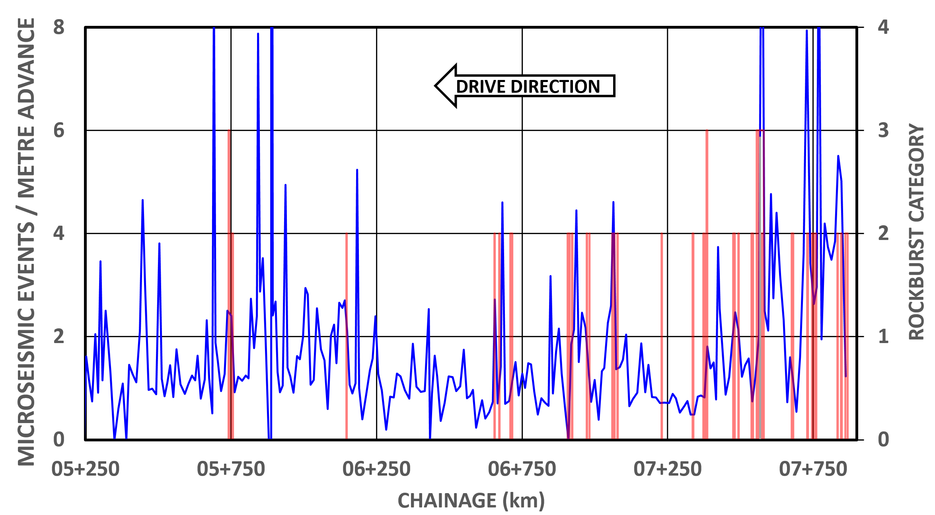
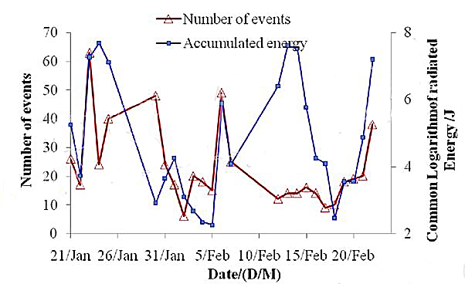
- A geographical to-scale representation of the two tunnels, viewed from above, showing the measured MS events as 3D textured spheres, with the size of the sphere representing the energy of the event, and the colour representing the time; the TBM face marked by a line (Figure 6).
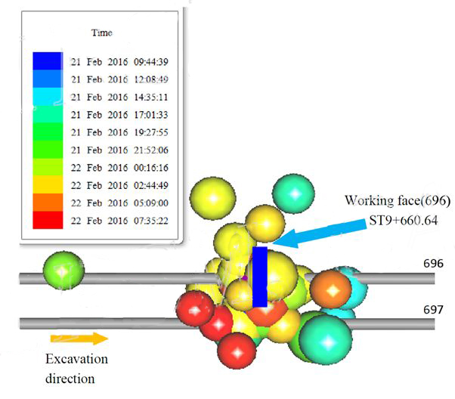
Figure 5. Typical daily report of Microseismic Event Count and Accumulated Energy vs Time
Figure 6. Typical daily presentation of spatial / temporal distribution of Microseismic events
The predictive capability of the MS monitoring system proved highly successful, particularly where the rockburst frequency was high. This is apparent for the left TBM data, even though the high rockburst frequency zone was missed in that drive. Figure 7 plots the number of MS events per metre of TBM advance (blue line) and the geographic location of observed rockbursts (red histogram), with the height of the bar denoting the magnitude of the rockburst. While the correlation in the later part of the drive is less obvious, the microseismic event spikes correlate well with recorded rockbursts over most of the chart. Much analytical work remains to be done, particularly for the right TBM, to determine relationships between the MS data and observed rockbursts. Suffice it to say that the daily reports provided timely, reliable and realistic forecasts that significantly increased TBM crew confidence, and allowed timely implementation of countermeasures.
Figure 7. Comparison of microseismic event count per metre of left TBM advance count (blue line - left vertical axis) with observed rockbursts by category (red histogram - right vertical axis). Entire length MS-monitored zone shown.

Conclusions
Many of the advantages of TBM tunnelling over conventional excavation can be significantly negated by the occurrence of rockbursts. Rockbursts invariably occur under high overburden, which imposes limitations of the type and extent of pre-construction site investigation possible, and commonly in tectonically active mountain chains, where high stresses may exist that can be difficult if not impossible to predict. Consequently, if rockbursts are likely on any TBM project, a robust method of routinely predicting rockbursts ahead of the TBM face must be incorporated into the TBM design, as well as its operating procedures. Specifically, these should include the following elements:
- Powerful percussion drill(s) for advance probing, located as close as possible to the face, with easy hole collaring capability, and an ability to drill anywhere on the tunnel circumference. Any probe holes will act as stress relief holes should rockburst potential be identified. Any technique that enhances the usefulness of these probe holes, such as automated parameter logging and use of downhole cameras should be readily implemented.
- Quick establishment after commencement of excavation of TBM boring parameters that result in optimal progress with minimal damage to the tunnel perimeter, but which also permit recognition of rock mass conditions most likely to result in rockbursts.
- Adoption, (or at least consideration of adoption if the probability of rockbursts is uncertain) of a state-of-the-art microseismic monitoring system that, in combination with the advance probing, will provide the best possible prediction of rockbursts currently available in a TBM excavation environment.
- Although not covered under the topic of short-term rockburst prediction that forms the basis of this paper, every effort should be made to better understand the rockburst phenomenon that is occurring, including implementation of in-situ stress measurements and specialist lab-testing of rock samples from rockburst-prone layers.

acknowledgements
The authors gratefully acknowledge the assistance in preparing this paper from the Water and Power Development Authority and the Institute of Rock and Soil Mechanics of the Chinese Academy of Sciences.

References

Chen BR, Feng XT, Li QP, et al. 2015. Rock Burst Intensity Classification Based on the Radiated Energy with Damage Intensity at Jinping II Hydropower Station, China. Rock Mechanics and Rock Engineering. 2015;48(l):289-303.
Code of China, 2008. GB50487-2008 Code for engineering geological investigation of water resources and hydropower (English)
Guang-Liang Feng, Xia-Ting Feng, Bing-rui Chen, Ya-Xun Xiao, Yang Yu. 2014. A Microseismic Method for Dynamic Warning of Rockburst Development. Processes in Tunnels. Rock Mechanics Engineering.
Heidbach, O., Tingay, M., Barth, A., Reinecker, J., Kurfeß, D., and Müller, B. 2008. The World Stress Map database release; doi:10.1594/GFZ.WSM.
Kaiser P.K. & McCreath D.R. (1993). Rock mechanics considerations for drilled or bored excavations in hard rock. Tunnelling and Underground Space Technology, 9 (4), 425-437.
Kaiser P.K, McCreath D.R. & Tennant D.D. (1996). Canadian Rockburst Support Handbook. Geomechanics Research Centre / MIRARCO
Xia-Ting Feng, Xiao Yashun and Feng Guangliang. 2012. Mechanism, Warning and Dynamic Control of Rockburst Evolution Process. ARMS7- 7th Asian Rock Mechanics Symposium. Seoul, South Korea.

